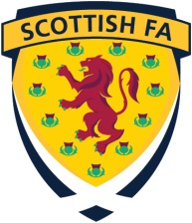
Scottish Football Association

REINSTATEMENT FROM PROFESSIONAL STATUS TO AMATEUR STATUS

FULL NAME

ADDRESS & POSTCODE
PLACE OF BIRTH

DATE OF BIRTH

NAME OF CLUB(S) FOR WHICH YOU WERE REGISTERED AS PROFESSIONAL

NAME OF CLUB WITH WHICH YOU LAST PLAYED AS A PROFESSIONAL

DATE ON WHICH PLAYED LAST PROFESSIONAL MATCH

I hereby request reinstatement from professional to amateur status in terms of Article 78.3.

IMPORTANT - Please ensure you send a copy of your birth certificate, driving licence or passport with this application - do not send original documents.

SIGNATURE
DATE

Please return this form and relevant documentation to:
Registrations Department, Scottish Football Association, Hampden Park, Glasgow G42 9AY

Enquiries:
Telephone nos: 0141 616 6051/6052/6053/6054 Fax no.: 0141 616 6055
Website: www.scottishfa.co.uk Email: registrations@scottishfa.co.uk

* FOR REINSTATEMENT TO BE GRANTED, 30 DAYS MUST HAVE ELAPSED SINCE YOU LAST PLAYED A MATCH AS A PROFESSIONAL

